MIGRATE – 1st International Summer School & Workshop
Registration Form

Date: June 27 – 28 and June 30 – July 1, 2016
Venue: Strasbourg, France
Local organizers: ICPEES – University of Strasbourg

Please return this registration form not later than June 1st, 2016 to: registration@migrate2015.eu

Note: Fees include the participation costs to the events, lunches and coffee breaks. Dinner, travel and hotel are at the cost of each participant.

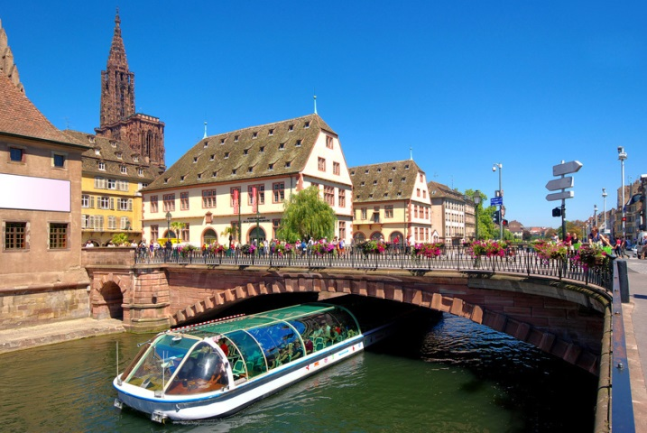

First Name: Please click to add text Last name: Please click to add text
Gender: ☐female ☐male
E-mail Address: Phone:
Institution:
Address:
Name and Institution as it should appear on the name badge:

I will attend the 2-day Summer School:
☐ Summer School fees: € 300
☐ Student fees € 250

I will attend the 2-day Workshop:
☐ Workshop fees: € 250
☐ Student fees: € 200

Combined registration (Summer School and Workshop):
☐ Regular fee € 450
☐ Student fees € 400

Nota Bene: Registrations done after June 1st, will lead to an extra cost of 50 € for the Summer School or the Workshop and 100 € for a combined ticket.

Meals (please indicate which meals you will join or not):
Date | Time | Event | Yes | No | Tentative
June 27 - am |  | Coffee break | ☐ | ☐ | ☐
June 27 |  | Lunch break | ☐ | ☐ | ☐
June 27 - pm |  | Coffee break | ☐ | ☐ | ☐
June 28 - am |  | Coffee break | ☐ | ☐ | ☐
June 28 |  | Lunch break | ☐ | ☐ | ☐
June 28 - pm |  | Coffee break | ☐ | ☐ | ☐
June 30 - am |  | Coffee break | ☐ | ☐ | ☐
June 30 |  | Lunch break | ☐ | ☐ | ☐
June 30 - pm |  | Coffee break | ☐ | ☐ | ☐
July 1 - am |  | Coffee break | ☐ | ☐ | ☐
July 1 |  | Lunch break | ☐ | ☐ | ☐
July 1 - pm |  | Coffee break | ☐ | ☐ | ☐

Dietary wishes/needs: ☐ halal/kosher ☐ vegetarian ☐ other Please click to add text

Payment terms

The payment of the Summer School and Workshop fees according to your selection made above has to be addressed in advance. Please pay the respective amount to the following account:

Account holder: KIT, Kaiserstrasse 12, 76131 Karlsruhe
Reference: MIGRATE ST-TC 45
IBAN: DE18 6005 0101 7495 5012 96
BIC: SOLADEST
Name of Bank: Baden-Wuerttembergische Bank, Stuttgart

Note that your registration will be confirmed, only after your payment receipt was noticed on our account. You will receive an invoice and more information on the event later on.

In case of further questions please contact: registration@migrate2015.eu

